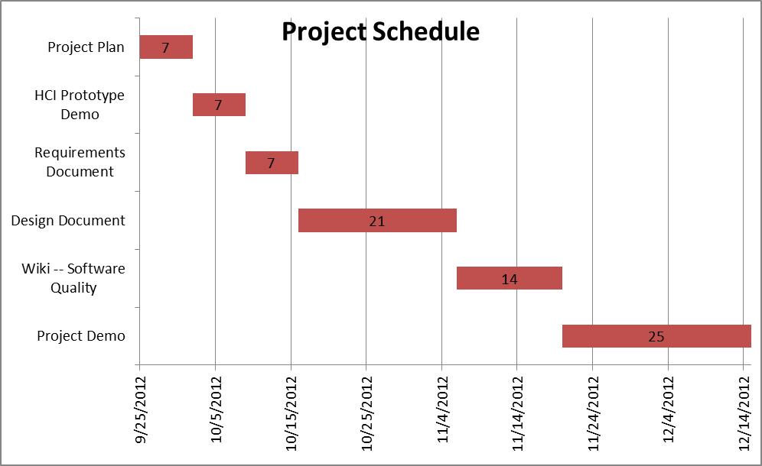
Minimal:
- Create a text based interface.
- Satisfy the rules of the game (we can list the rules if you want).
- There should be a winner in the game.
- Satisfy up to three players
Target:
- Create a GUI based interface.
- Satisfy the rules of the game (we can list the rules if you want).
- There should be a winner in the game.
- Satisfy up to six players
Dream:
- Create a visual game.
- Satisfy the rules of the game (we can list the rules if you want).
- There should be a winner in the game.
- Satisfy up to six players
- Have it be an online version of the game.
- Port it over to an Apple or Android app store to have more customers.

